**FORMAN CHRISTIAN COLLEGE (A CHARTERED UNIVERSITY)**



**CSCS 468 Mob App Development**

**Section A**

**M Umair Shafiq 251697475**

**Homework 1**

**Task 1**

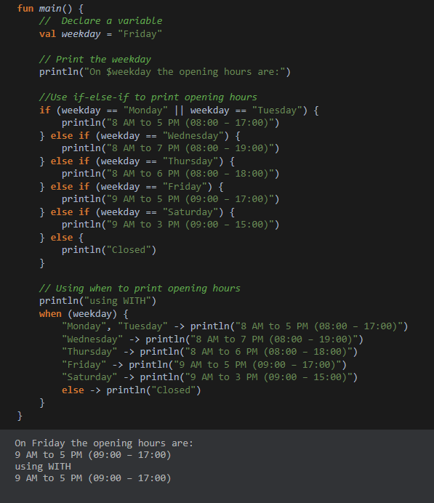

**Task 2**

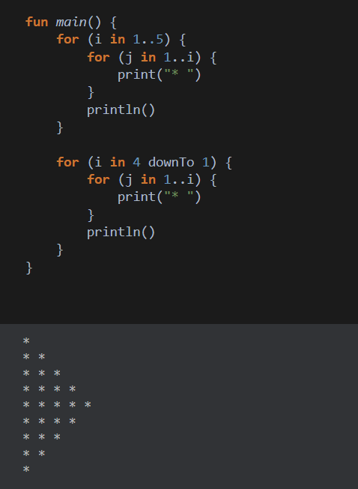

**Task 3**

